# § 1 – Colonization and landscape

G-Numbers: G58

# § 2 – Climate and the forces of nature

G-Numbers: G30, 33, 36, 37, 38, 39, 40, 41, 51, 52

# § 3 – Melting pot or salad bowl

G-Numbers: G117, 118, 120, 124

# landscape usa.jpg§ 1 Colonization and landscape

* **The shifting frontier**
* Colonization:   
  making a region fit for human use
* Until 1840, low immigration in USA, then Europeans came
* The frontier is the division between the western and eastern part of USA.
* **Landscape at forty degrees latitude**
* When you travel from east to west, you see landscape clearly change.
* The Appalachians (low) are found in east, it’s an old mountain range: erosion
* The Rockies (high) in the west, is a young mountain range (Alps), sharp peaks and perpetual snow.
* The inferior Central plain, found in the middle, is a coastal plain. (Corn belt)
* The Great plains, further to the west, have natural vegetation (steppe), only with irrigation (Weat belt)
* The Great basin, extremely dry, rain closer to the coast
* Central Valley, is in rain shadow by surrounded mountains.

# § 2 Climate and the forces of nature

* Hot air comes from south (gulf of Mexico), cold air comes from north (Canada)
* Dust storms: in western part, high temperature, dust blown in air
* Hurricanes: south east, above +27c seawater occurs, loose strength when on land
* Flash floods: soil on bare slopes is taken away, roads disappear
* Floods: Drainage basin (Mississippi), wind north and south meets
* 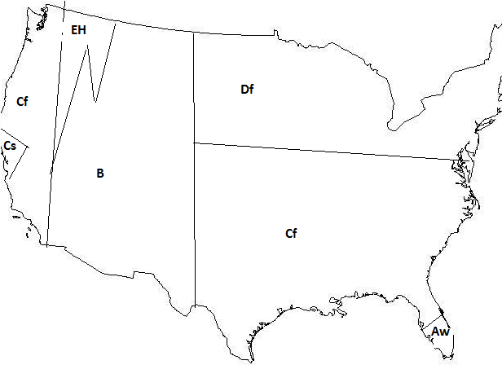Tornado: middle, land and sea wind meets

# § 3 Melting pot or salad bowl

* **Countries of origin:**
* <1800 slaves
* 1800 > 1960 white Europeans (2/3 USA European)
* > 1960 other groups
* Afro-Americans, they moved to north-east industrial cities
* Hispanics, Mexican border, work in agriculture, Spanish 2nd language
* Asian, west + big cities, model minority (have made it), also poor from e.g. Laos
* **Melting pot:**
* Melting pot: being proud of their country and integrate. This started good, till East and South Europeans came. They had their own neighbourhoods
* Hispanics and Asians, stay with their family (family formation) and live in a own ethnic neighbourhood with own language.
* The melting pot has changed into a salad bowl, where all parts are still able to recognizable.

# G58 Relief

* Relief = height difference
  + High mountain ranges: peaks > 1500m
  + Low mountain ranges: peaks 1500 – 500m
  + Hills: peaks 500 – 200m
  + Lowlands: peaks <200m
* Plain = a region with very little/no relief
  + Coastal plain: <500m
  + Plateau: >500m

# G30 Temperature factors

* The following factors influence temperature: latitude, attitude and land-sea distribution

# G33 Latitude and temperature

* North and south pole are colder because of diagonal light rays from the sun.
* Closer to the equator it’s warmer because of vertical light rays
* Vertical rays are warmer because they hit a smaller surface and have to travel shorter distances

# G36 Temperature above sea and land

* Land cools down/ warms up more easily than sea. 🡪 land has extreme temperatures. This also counts for the air above land / sea. (air at sea is more stable)

# G37 Onshore and offshore winds

* Onshore winds = wind from sea (less temperature difference)
* Offshore winds = wind from land (more temperature difference)

# G38 Ocean currents

* Wind causes ocean currents, this influences temperature on land.

# G39 Location of mountains

* A mountain can separate two climates, it makes it difficult for the wind to cross it. But temperature in the mountain stays longer (cold winters, warm summers).

# G40 The causes of precipitation

* Air rises 🡪 cools down 🡪 can’t hold weight 🡪 rains

# G41 Precipitation in mountains

* Windward side = place where wind reaches mountain (relief rainfall)
* Leeward side = Other side of mountain (rain shadow 🡪 dry)

# G51 Köppen’s climate classification system

|  |  |  |  |  |  |
| --- | --- | --- | --- | --- | --- |
| 1st letter |  | 2nd letter (small) | Precipitation  (A, C, D) | 2nd letter (capital) | Where  (B, *E*) |
| A | Tropical | F | Fehlt (all year) | W | Wüste |
| B | Dry | S | Summer | S | Steppe |
| C | Maritime | W | Winter | H | Hochgebirge |
| D | Continental |  |  | *T* | *Tundra* |
| E | Polar |  |  | *F* | *Ice sheet* |

# G117 Immigration and emigration

* International migration: move from one to another country
* Push factors makes people want to leave
* Pull factors makes people want to life somewhere else

# G118 Push factors and pull factors

|  |  |  |
| --- | --- | --- |
| Type of reason | Push | Pull |
| Economic | Unemployment | Jobs  Education |
| Political | War  Discrimination | Freedom of speech |
| Physical | Climate  Earthquake | Climate |

# G120 Newcomers and natives

* First-generation: born abroad
* Second-generation: parents born abroad
* Alien is not the same as immigrant

# G124 Multicultural society

* A country can be multi-cultural
* The cultural / ethnic minorities are the groups from other culturs
* Spatial segregation: different groups living separated
* Social segregation: live in own group (neighbour can be Dutch)
* Assimilation: newcomers trying to adopt as much as possible
* Integration: becoming part of a larger group (both groups need to tolerate

each other)